Welcome Game Changer

Let me be very clear…I want to see you WIN!

I believe you have registered for this strategy camp because you are ready to take your business to the next level and get serious about
making the money you have dreamed about while making
a difference.

Perhaps you’ve tried the latest marketing strategy, you’ve read the latest sales and marketing book and you may have even hired a business coach but yet you still haven’t achieved the success you desire. I know it can be frustrating and maybe even a little devastating to struggle and see your dreams go unfulfilled.

It doesn’t have to be this way, and you are not alone!

I believe you were divinely created for greatness. There are people waiting for you to show up and provide the
help, support or solution they need to be successful.
Don’t give up! Don’t let them down. The impossible becomes possible with the right information and the right coach. I am here to
help you on your journey.

This journey will be one of the most powerful investments you will ever make in your business. I am going to help you shift your thinking, expand your vision, tap into your potential and reveal what’s truly possible for you. You will take your business to the next level if…

YOU DO THE WORK!

Nothing will replace your sweat equity in building a successful and profitable business. You can’t delegate it, buy it, outsource it or borrow it. I promise if you do the work, God will open up a floodgate of blessings that you won’t even have room enough to receive it. Are you ready to play like a game changer and WIN big? Then Let’s get started…

Lethia Owens

Things You Should Know

Here are details I want to make sure you have at your fingertips regarding our time together. If you need assistance while in town, call my team at (800) 670-0712.

Hotel
Hilton Garden Inn St. Louis Airport · Phone: (314) 521-6444
4450 Evans Pl, St Louis, MO 63134 · United States

Your registration includes 1 night (Friday) hotel accommodations. There is nothing more you need to do. My team will assign you a roommate. If you would prefer a private room, please contact my office to make arrangements. If you are flying in a day early, don't forget to contact my office to add an additional day to your stay. Additional days are not covered by your registration for the event and are your responsibility.

Schedule
Friday | Saturday
9:00 am – 12:30 pm Day 1 Session 1 | 9:00 am – 12:30 pm Day 2 Session 1
12:30 pm – 1:30 pm Reflective Lunch | 12:30 pm – 1:30 pm Reflective Lunch
1:30 pm – 5:00 pm Day 1 Session 2 | 1:30 pm – 5:00 pm Day 2 Session 2
6:00 pm – 7:30 pm Dinner with Lethia and
Surrender Your Way to
Success.

Transportation Details
If you are traveling by air, you will fly into the STL airport. The airport is less than 5 miles from our host hotel.
If you are flying in for the event, please be sure to email your itinerary to Amy Baue (Amy@LethiaOwens.com) so she can make note of your arrival time. The hotel provides a shuttle to and from the airport and it runs by request. When your flight touches down, make the call to the hotel to let them know to send the shuttle as it take up to 20 minutes for the shuttle to arrive. The hotel's phone number is listed above.

Pre-Work Instructions

Setting time aside to complete the following pre-work assignments will help you mentally prepare for our 2-day strategy camp and position you to get the most out of our time.

Ok I know you may be thinking…”Well Lethia, what if I don’t have answers for some of the question?”

I totally get it and I understand. If you don’t have an answer to a question please give it your best try. If the exercise addresses an area of business that you just honestly are not prepared to address, don’t sweat it. Give it YOUR BEST and know that we will explore these concepts in detail during our time together.

Required Action on Your Part:
Once you have completed this editable PDF Form, please email a copy to info@callkayla.com. The deadline to complete this action item is Sept 18, 2015.

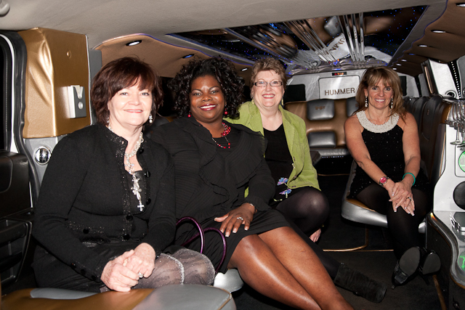
I will personally review the pre-work of every participant to help me prepare to provide the highest service possible to you during our two days together.

I am so looking forward to working with you!

Step 1 – Developing the Mindset of a Game Changer

During our time together, we will work to create a brand message that truly embodies the essence and power of who you really are in attitude, philosophy, action and expertise. In order to accomplish this we will need to take some time to really dig deep and become clear about the type of brand and business you want to create. It is essential that you prepare your mind to start thinking like a game changer.

I want to encourage you not to think of this work as “hard” because it doesn’t have to be. “Digging deep” is not always “hard work”. Imagine, if you will, that the discovery and transformation process could be easy for you, that the answers you seek WILL be revealed just as you need them and your next step will emerge right when you are ready.

Your mindset as we approach this process will determine the quality and value of your experience.

Digging Deep

What is Your Purpose (The calling, work or mission that drives you to do what you.)?

What is Your Why (The real motivation behind your reason for wanting to make your business successful.)?

What is the next level of meaning for me in my work? What does it look like and feel like?

What is the message you want to share with the world?

Your Competitive Advantage:
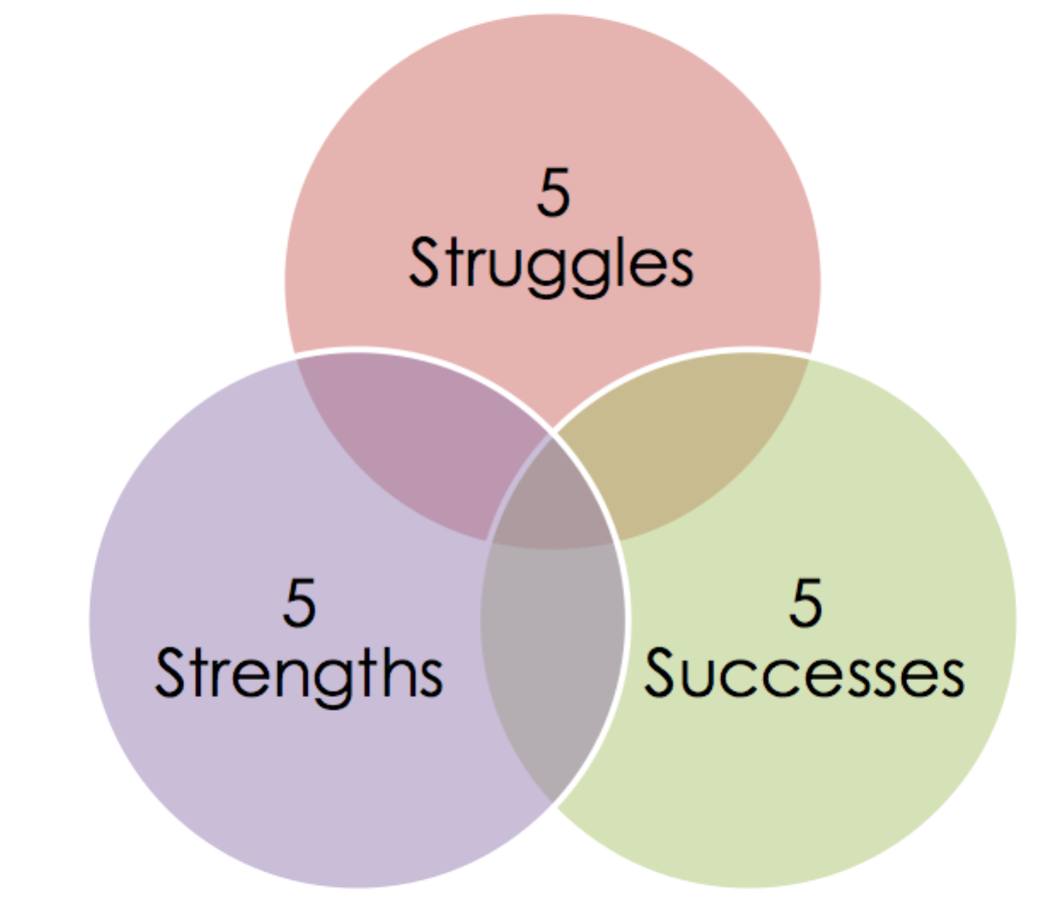
The connection between branding, marketing and the next few exercises may not be clear but I guarantee you that this step in the process is essential. Please be as descriptive as possible.

List 5 struggles you have faced that have shaped who you are:

List 5 successes you have faced that have shaped who you are:

List 5 strengths you possess. Some may be natural and some may have been developed as a result of the struggles and successes you have experienced.

Your Unique Value Proposition – In what ways do you add value to your clients because of the struggles or successes you have experienced or as a result of the strengths you possess?

What is the primary thing your customers want?

What is it about you that makes you an exceptional person people would want to follow?

10 Beliefs I Hold About Myself
Take a moment and write down 10 beliefs you hold about yourself:

10 Beliefs of My Work
Take a moment and write down 10 beliefs you hold about the work you do. These are the key principles, strategies, wisdom and beliefs you hold and want to communicate to your tribe members. For example these would be the 10 beliefs I have about being a game changer.

Step 2 – Let’s Evaluate Your Current Brand

As we begin the process of building your magnetic brand and market domination strategy, it is important to start with an evaluation of your current brand.

Brand Name
Your brand name is the word or phrase that embodies the essence of your brand. It is the label for your body of work, which describes who you are and what you have to offer. It will become the main label for your message and will be used in your marketing.

Examples: "Progressive" “State Farm” "Dare to Be Irresistible" “Believe the Invisible, Achieve the Impossible”

Record your brand name ideas below:

Tagline
Easy, memorable recognizable, often accompanies a brand name. The phrase that helps people link the name of your business to brand message.

Examples: "Just do it." “Like a Good Neighbor, State Farm is there” “Be All You Can Be”

Record your tagline ideas below:

Target Market
If you want to truly connect with your target market, any marketer will tell you, about the importance of defining your target market profile. This means establishing exactly who you’re directing your products and services at. These are the people who desperately want and need what you’ve got!
Your clients have been predestined to work with you before the foundation of this world was even created and they are waiting on you to show up as the solution they have been looking for. It is essential that you learn to connect with them using your true voice so you can share your story in an authentic, relevant and meaningful way. When you do this your message becomes powerfully magnetic. When your message is magnetic, it will draw and attract your ideal clients, thus giving you a hungry buying audience eager to pay for your products and services.

To help you find your true voice and magnetically connect with your target audience, let’s dig deep.

What are the Pleasures, Desires, Wants, Goals, Focus and Interests of the people you want to reach? (List as many as you can think of for this exercise.)

What is the Pain, Struggle, Uncertainty, Overwhelm and Fatigue of the people you want to reach? (List as many as you can think of for this exercise.)

When you think about the people who are most drawn to your message and your work, they are people who:

Dream of…

Are afraid to or afraid of…

Follow these leaders/teachers…

Strongly dislike or are turned off by…

Are inspired by…

Have the following needs…

Spend their time online…

Don’t hesitate to invest in…

Demographics:
Facts such as age, gender, race, family size, status, income, education, geographics, and occupation.

Examples:

- Example 1 - Been in business for at least five years and has an annual revenue of 100K or more
- Example 2 – Has a young family and owns a home
- Example 3 – Has a credit score of 700 or more
- Example 4 – Lives within the U.S.

List the demographics of your target audience:

Psychographics:
The person's personality, psychological, attitudinal and lifestyle variables that focus on hopes, fears, interests, beliefs, values.

Questions to ask yourself:
- What do they do in their spare time?
- What magazines or newsletters do they read?
- What movies or TV shows do they watch?
- What websites or portals do they visit for information?
- What do they do for vacation?
- What are their professional activities outside of work?

Examples:

- Example 1 - Think of themselves as goal oriented and dreams of a successful future
- Example 2 – Is an avid reader and is focused on personal development
- Example 3 – Watches TV shows such as National Geographic, The Food Network and HGTV
- Example 4 – They serve on the board of a non-profit organization

List the psychographics of your target audience:

Sociographics:
(On and off the social networks, the groups your target market associates in and with, can say a lot about what they really believe.)

Questions to ask yourself:
- What social networks are frequented by members of my target market?
- What activities do members of my target market participate in online?
- Where do members of my target market spend money online?

Examples:

- Example 1 - Power they have within their sphere of influence
- Example 2 - Influential reputation within their network

List the sociographics of your target audience:

Expertise
The comprehensive and authoritative knowledge or skill you have in a particular area.
Example - Expertise in magnetic branding and digital marketing.

Define the expertise and skills you possess either through formal training or experience:

Niche
Define the problem you solve for your target market.

Your Niche = Who (Your target market) + What (The problem you
help them solve or need your fulfill)

Example - Helping game changers get noticed, hired and paid what they’re worth.

Define the title that best describes how you want to be viewed within the marketplace:

Title
As an expert, your title will be the formal label prospects and customers use to identify you. It should be clear and memorable.

Define the title that best describes how you want to be viewed within the marketplace:

Step 3 – Monetize Your Message

The 2nd part of our strategy camp will focus on helping you monetize your message. The following questions cover the pre-work needed for this portion of our work together.

Your Signature Programs, Products and Services
A list of unique offerings that support your brand and provide the foundation for your body of work. List the descriptions for your programs, products and/or services.
Please use the following format for each of your products:
Product Name: Market Domination for Game Changers 2-Day Strategy Camp
Price: $1,297
Delivery Format: Live Event
Description: A 2-day event to help clients brand their brilliance, monetize their message and dominate their market.

*Delivery formats can include - Book, Live Event, Face-to-Face, Virtual, Online,
Download, Etc.

Enter your programs, products and services below:

Your Signature Programs, Products and Services (Cont.)
Enter your programs, products and services in the space provided below. Please use the following format for each of your products:
Product Name: Market Domination for Game Changers 2-Day Strategy Camp
Price: $1,297
Delivery Format: Live Event
Description: A 2-day event to help clients brand their brilliance, monetize their message and dominate their market.

Your Signature Programs, Products and Services (Cont.)
Enter your programs, products and services in the space provided below. Please use the following format for each of your products:
Product Name: Market Domination for Game Changers 2-Day Strategy Camp
Price: $1,297
Delivery Format: Live Event
Description: A 2-day event to help clients brand their brilliance, monetize their message and dominate their market.

Your Signature Programs, Products and Services (Cont.)
Enter your programs, products and services in the space provided below. Please use the following format for each of your products:
Product Name: Market Domination for Game Changers 2-Day Strategy Camp
Price: $1,297
Delivery Format: Live Event
Description: A 2-day event to help clients brand their brilliance, monetize their message and dominate their market.

Step 4 – Preparing for Market Domination

Our final area of focus is market domination. The following questions will help evaluate your current marketing strategy so you can identify the opportunities for enhancing your process. We’ll take a look at your social media and website activities and create the first draft of your magnetic marketing message.

Social Media Audit
Let’s take a look at your current use of social media tools. If something isn’t applicable just enter N/A.

Social Media Metric | Quantity
Facebook Likes:
Facebook Subscribers:
Twitter Followers:
LinkedIn Connections:
LinkedIn Followers:
Google+ Connections:
YouTube Subscribers:
YouTube Total Views:
Klout Score (from http://Klout.com):
Pinterest Followers:
Instagram Followers:
Tumblr Followers:
SoundCloud Plays:
iTunes Subscribers:

Website Audit

Now let’s take a look at your current website if you have one. We want to identify how effective it is in helping you market your products and services.

The key to developing a branded and optimized website is to be clear, concise, complete and consistent in outlining who you are, what you do and how clients benefit from working with you. Here is an outline you can use to evaluate the effectiveness of your current website. Check the box for each item you have successfully implemented on your website.

Your website generates revenue for you in the form of product/service sales.

Home Page – A brief outline of the essence of your business and brand are clearly communicated.

Who We Serve – You have a page that clearly communicates who you serve and the problems and challenges you help them solve. It also gives the profile of an ideal client – “We are most likely to be successful working together if…”

How We Work – You have a page that gives a sense of what it’s like to work with you. You share your beliefs, values, philosophy, etc. It also discusses the kind of results you produce for your clients.

Services – You have a page that gives an overview of the various services you offer, how they work and the advantages and benefits of those services.

Clients/Case Studies You have a page that provides a list of client’s you’ve worked with and testimonials of successful projects.

About Us – You have a page that contains background material on the company and principal(s) of your company. It must answer the question, “How are you qualified to help me?”

Articles/Blog – You have a page that includes articles and/or blog posts on topics related to your field of expertise. The more you prove what you know, the more credibility you’ll gain and the easier it will be to close the sale. Let’s you best work shine.

Resources/Store – You have a page that shares other relevant material that would be of interest to a client – links to other websites, a book list, questionnaire, etc.

FAQ Page – You have a page that lists frequently asked questions that could be useful in summarizing what you do and the benefits you offer.

Media Page – You have a page that highlights your media appearances or information to help the media decide to interview you.

Contact Us – You have a page that tells the visitor how to get in touch with you.

Responsive – Your website is mobile friendly and uses a responsive design.

Your phone number and/or email address is included in the header of your website so it appears on every page.

Free Offer Opt-in – You provide an incentive for people to sign up for your email list by offering them something of value in exchange for their email address.

Your brand name, contact details, tagline, opt-in (Call-to-Action), brand message appear above the fold on the home page.

Search Engine Optimization - Your copy has been optimized to help you rank on search engines such as Google, Bing and Yahoo.

Social Share – Your web pages and blog posts provide an easy way for users to share your content on their social media networks.

Legal – Your footer includes a link to your privacy policy and terms of use.

Current Marketing Strategy
Use the chart below to document your current marketing strategies.

Activity | 1=Currently Use, 2=Plan to Use, 3=No Plans to Use | URL
Twitter
Facebook Biz Page
Facebook, YouTube
or LinkedIn Ads
Blogging on LinkedIn
Pulse
YouTube
Pinterest
Instagram
Blogging

Video Marketing
Podcast

Keywords
If you have specific keywords you have been using as part of your search engine optimization, please list them below:

Email Marketing
- What Email Marketing tool do you use?

- What is the size of your list?

- How frequently do you email your list?

Magnetic Free Offer (Your Email Opt-in)
Your magnetic free offer is used to attract clients into your sales funnel. Here are some pointers to keep in mind:

- It’s FREE.
- It is compelling and sought after – something that people would actually pay for, but are surprised and delighted they don’t have to.
- It contains valuable content that will help your target market in some way. It is NOT a throw-away item.
- It’s easy to give away – a discount, downloadable pdf or mp3, for example.
- It is a natural lead-in to your other products and services. It gives people a “taste” of your work and leaves them wanting even more.

Describe your Magnetic Free Offer below. If you don’t have one, take a stab at creating a draft description of one you would want to offer:

Create the First Draft of Your Magnetic Marketing Message
When someone asks what you do, it is important that your response helps you stand out. Contrary to conventional wisdom and what you may have been taught, you don’t want to start out by sharing what you do and how you can help the other person. What most people tend to do is focus on what they do, their services and processes. The key to standing out and making a powerful connection with the prospective client is to address their pain or desire for pleasure. This takes the focus off of you and puts it on the prospective client, giving them an opportunity to learn what you do through the lenses of their own needs. This always generates a better initial conversation about your products and services.

This method is simple yet powerful in that this small tweak to how you share your message will gain greater interest and attention for your products and services.

So when asked, “What do you do?”, respond with a powerful and magnetic marketing message.

Here is an example for you to follow:

- Problem Statement – Articulate the problem or predicament or pain your target market is experiencing in terms that are meaningful to the person you are speaking with.
“I have found that most entrepreneurs know they need to build a brand that is distinctive and differentiates them in the market place but they just don’t know where to start.”

- Problem Story – Tell them more about the problem and discuss examples of those you have worked with.
“They often turn to studying their competitors as a way to position themselves more powerfully in the market place but instead of becoming more distinct, they end up becoming more and more like everyone else in the market. What happens is that they end up trying to be the better than their competitors. The key to standing out from the crowd is not being perceived as being the best at what you do. A magnetic brand is built on being perceived as being the ONLY ONE who does what you do.”

- Expertise – tell them who you are and what your expertise is in.
“As a personal branding strategist…”

- Target Market – Say who you work with to let them know your services are for them and not someone else.
“I work with speakers, authors, coaches and entrepreneurs.”

- Solution Statement – Tell them your solution and what makes you different.
“I help my clients define, package and promote their magnetic brand.”

- Benefits – Tell them how clients benefit when they work with you.
“When clients work with me they develop a clear brand message, generate more leads and referrals create more buzz for their brand and attract more ideal clients ready to pay premium fees. “

Now it’s your turn…
Let’s create the first draft of your Magnetic Marketing Message.

- Problem Statement – Articulate the problem or predicament or pain your target market is experiencing in terms that are meaningful to the person you are speaking with.

- Problem Story – Tell them a little more about the problem and discuss examples of those you have worked with. Keep it brief. (Optional)

- Expertise – tell them who you are and what your expertise is in.

- Target Market – Say who you work with to let them know your services are for them and not someone else.

- Solution Statement – Tell them your solution and what makes you different.

- Benefits – Tell them how clients benefit when they work with you.

Hot Seat Application
If you would like the chance to be placed in the hot seat and get laser coaching from Lethia during our strategy camp, please complete the following questions:

Describe in detail the challenge you would like Lethia to help you with:

What have you already done to address this challenge?

What has kept you from getting the results you desire in this area?

What does success in this area look like to you?

