Lethia’s Recommended Reading List:
50 Must Read Books to Help Build a Powerful Professional Brand

The Servant Leader 3
The One Thing You Need to Know 4
Blue Ocean Strategy 5
Developing the Leader Within You 6
Be Your Own Brand 7
Becoming a Person of Influence 8
The Brand You 50 9
The Carrot Principle 10
Earn What You're Really Worth 11
Fascinate 12
Go Put Your Strengths to Work 13
How to Win Friends And Influence People 14
The Inspiring Leader 15
The Leadership Challenge 16
Never Eat Alone 17
Nice Girls Don’t Get the Corner Office 18
Talent Is Never Enough 19
Time Tactics of Very Successful People 20
Winning With People 21
Work Like You’re Showing Off! 22
Yes! 23
Make Difficult People Disappear 24
Lead with a Story 25
What Matters Now 26
Your Best Just Got Better 27
Y-Size Your Business 28
The Steve Jobs Way 29
The Extraordinary Coach 30
The 7 Habits of Highly Effective People 31
The 4 Disciplines of Execution 32
StandOut 33
Ownership Thinking 34
One Big Thing 35
Judgment Calls 36
How to Stop Worrying and Start Living 37
First Things Fast 38
AMA Business Boot Camp 39
All In 40
18 Minutes 41
Failing Forward 42
The Strategist 43
Greatness 44
The Power of Full Engagement 45
Relax, It’s Only Uncertainty 46
From Values to Action 47
Multipliers 48
Primal Leadership 49
The Fifth Discipline 50
The Wisdom of Crowds 51
What Got You Here Won’t Get You There 52

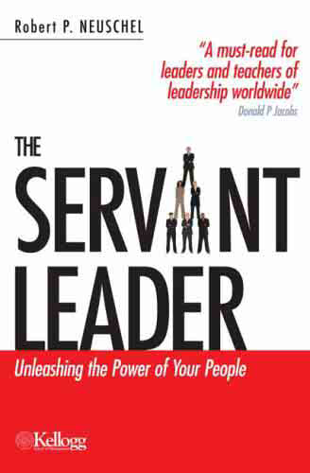
The Servant Leader
Unleashing the Power of Your People

Book Overview:
- “Servant leaders" use their power to benefit the people they lead.
- Leaders are made, not born.
- The foundation of leadership is integrity, which inspires trust.
- Trust your managers and they will trust you.
- Successful leaders are accessible, decisive and effective. Most of all, they have stamina.
- They are good managers who can think both tactically and strategically.
- To facilitate organizational change, you need good communication skills and a positive attitude.
- Train the next generation of leaders by delegating responsibility.
- Empower subordinates to make decisions, set expectations and evaluate performance.
- When you listen to others and serve them, they will follow you.

Click here to read reviews, extended summary and current pricing from Amazon.

Personal Notes About This Book:

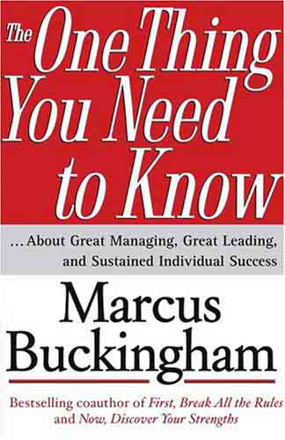
The One Thing You Need to Know
…About Great Managing, Great Leading, and Sustained Individual Success

Book Overview:
[paste take a ways here]

Click here to read reviews, extended summary and current pricing from Amazon.

Personal Notes About This Book:

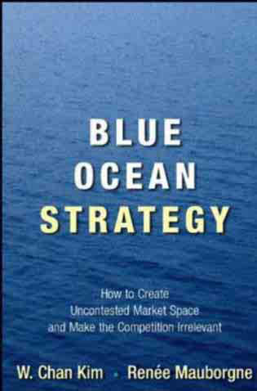
Blue Ocean Strategy
How to Create Uncontested Market Space and Make the Competition Irrelevant

Book Overview:
[paste take a ways here]

Click here to read reviews, extended summary and current pricing from Amazon.

Personal Notes About This Book:

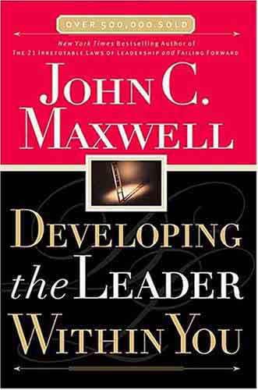
Developing the Leader Within You

Book Overview:
[paste take a ways here]

Click here to read reviews, extended summary and current pricing from Amazon.

Personal Notes About This Book:

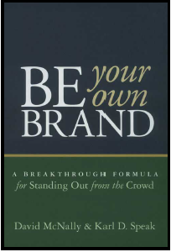
Be Your Own Brand
A Breakthrough Formula for Standing Out from the Crowd

Book Overview:
[paste take a ways here]

Click here to read reviews, extended summary and current pricing from Amazon.

Personal Notes About This Book:

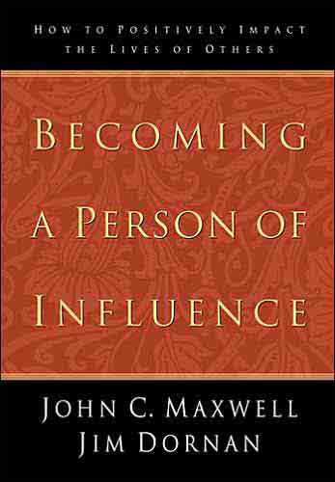
Becoming a Person of Influence
How to Positively Impact the Lives of Others

Book Overview:
[paste take a ways here]

Click here to read reviews, extended summary and current pricing from Amazon.

Personal Notes About This Book:

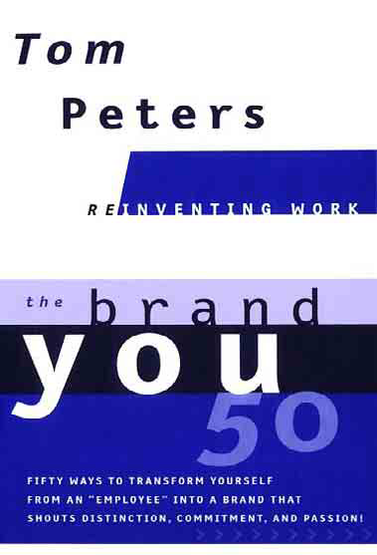
The Brand You 50
Fifty Ways to Transform Yourself from an “Employee”
into a Brand that Shouts Distinction, Commitment, and Passion!

Book Overview:
[paste take a ways here]

Click here to read reviews, extended summary and current pricing from Amazon.

Personal Notes About This Book:

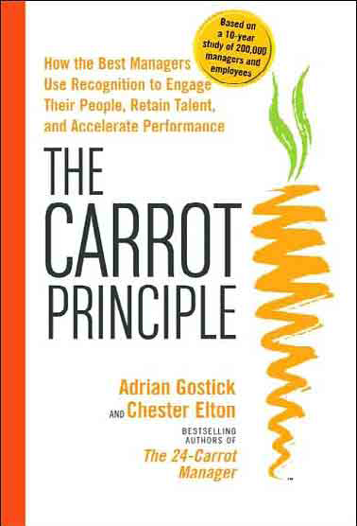
The Carrot Principle
How the Best Managers Use Recognition to Engage Their People,
Retain Talent and Accelerate Performance

Book Overview:
[paste take a ways here]

Click here to read reviews, extended summary and current pricing from Amazon.

Personal Notes About This Book:

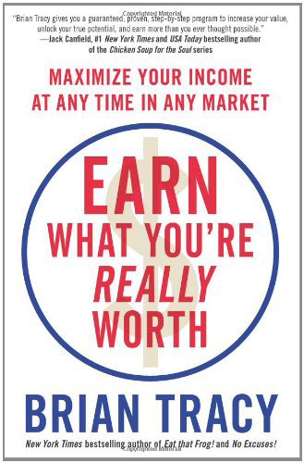
Earn What You're Really Worth
Maximize Your Income at Any Time in Any Market

Book Overview:
[paste take a ways here]

Click here to read reviews, extended summary and current pricing from Amazon.

Personal Notes About This Book:


Fascinate
Your 7 Triggers to Persuasion and Captivation

Book Overview:
[paste take a ways here]

Click here to read reviews, extended summary and current pricing from Amazon.

Personal Notes About This Book:

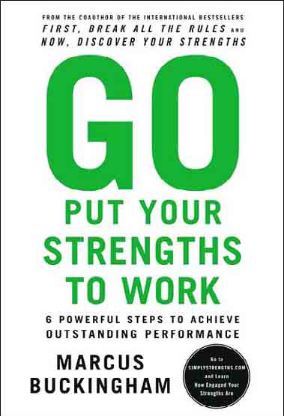
Go Put Your Strengths to Work
6 Powerful Steps to Achieve Outstanding Performance

Book Overview:
[paste take a ways here]

Click here to read reviews, extended summary and current pricing from Amazon.

Personal Notes About This Book:

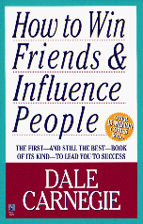
How to Win Friends And Influence People

Book Overview:
[paste take a ways here]

Click here to read reviews, extended summary and current pricing from Amazon.

Personal Notes About This Book:

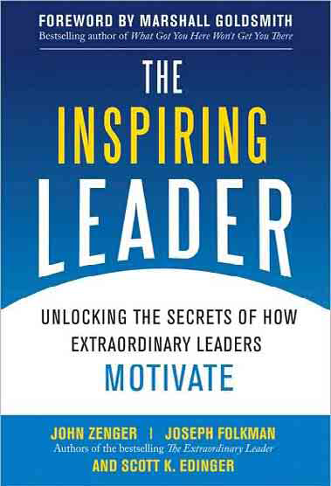
The Inspiring Leader
Unlocking the Secrets of How Extraordinary Leaders Motivate

Book Overview:
[paste take a ways here]

Click here to read reviews, extended summary and current pricing from Amazon.

Personal Notes About This Book:

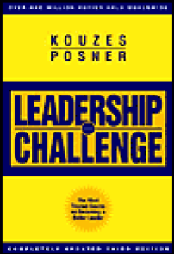
The Leadership Challenge
How to Keep Getting Extraordinary Things Done in Organizations

Book Overview:
[paste take a ways here]

Click here to read reviews, extended summary and current pricing from Amazon.

Personal Notes About This Book:


Never Eat Alone
And Other Secrets to Success, One Relationship at a Time

Book Overview:
[paste take a ways here]

Click here to read reviews, extended summary and current pricing from Amazon.

Personal Notes About This Book:


Nice Girls Don’t Get the Corner Office
101 Unconscious Mistakes Women Make that Sabotage Their Careers

Book Overview:
[paste take a ways here]

Click here to read reviews, extended summary and current pricing from Amazon.

Personal Notes About This Book:

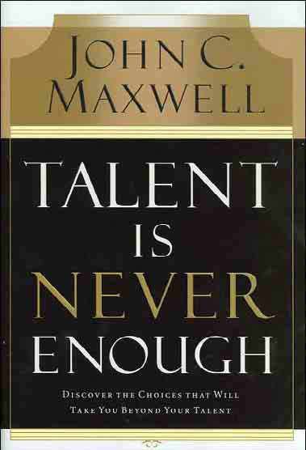
Talent Is Never Enough
Discover the Choices That Will Take You Beyond Your Talent

Book Overview:
[paste take a ways here]

Click here to read reviews, extended summary and current pricing from Amazon.

Personal Notes About This Book:

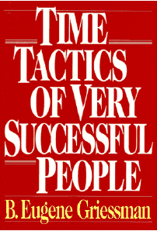
Time Tactics of Very Successful People

Book Overview:
[paste take a ways here]

Click here to read reviews, extended summary and current pricing from Amazon.

Personal Notes About This Book:

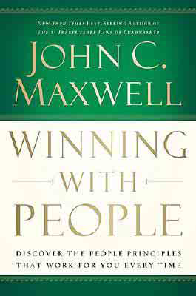
Winning With People
Discover the People Principles that Work for You Every Time

Book Overview:
[paste take a ways here]

Click here to read reviews, extended summary and current pricing from Amazon.

Personal Notes About This Book:

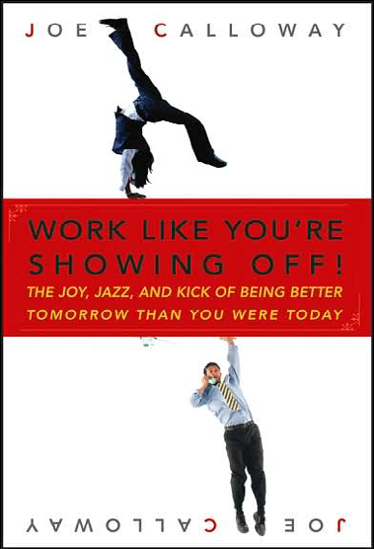
Work Like You’re Showing Off!
The Joy, Jazz, and Kick of Being Better Tomorrow Than You Were Today

Book Overview:
[paste take a ways here]

Click here to read reviews, extended summary and current pricing from Amazon.

Personal Notes About This Book:

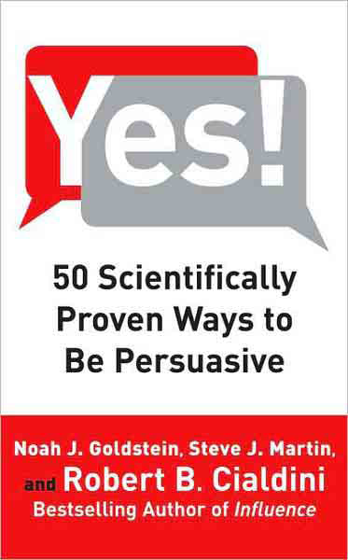
Yes!
50 Scientifically Proven Ways to Be Persuasive

Book Overview:
[paste take a ways here]

Click here to read reviews, extended summary and current pricing from Amazon.

Personal Notes About This Book:


Make Difficult People Disappear
How to Deal with Stressful Behavior and Eliminate Conflict

Book Overview:
[paste take a ways here]

Click here to read reviews, extended summary and current pricing from Amazon.

Personal Notes About This Book:

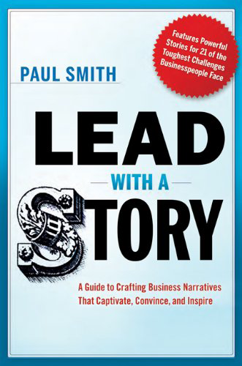
Lead with a Story
A Guide to Crafting Business Narratives That Captivate, Convince, and Inspire

Book Overview:
[paste take a ways here]

Click here to read reviews, extended summary and current pricing from Amazon.

Personal Notes About This Book:

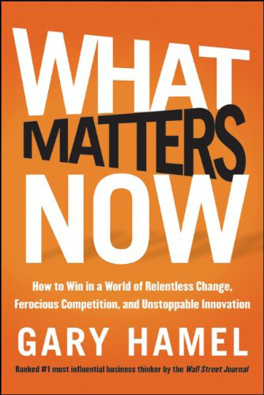
What Matters Now
How to Win in a World of Relentless Change, Ferocious Competition, and
Unstoppable Innovation

Book Overview:
[paste take a ways here]

Click here to read reviews, extended summary and current pricing from Amazon.

Personal Notes About This Book:

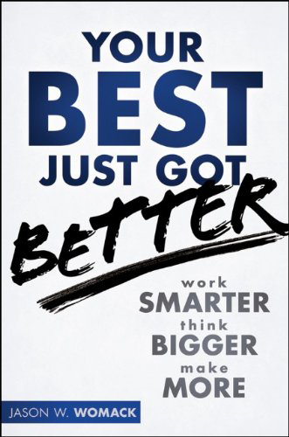
Your Best Just Got Better
Work Smarter, Think Bigger, Make More

Book Overview:
[paste take a ways here]

Click here to read reviews, extended summary and current pricing from Amazon.

Personal Notes About This Book:


Y-Size Your Business
How Gen Y Employees Can Save You Money and Grow Your Business

Book Overview:
[paste take a ways here]

Click here to read reviews, extended summary and current pricing from Amazon.

Personal Notes About This Book:

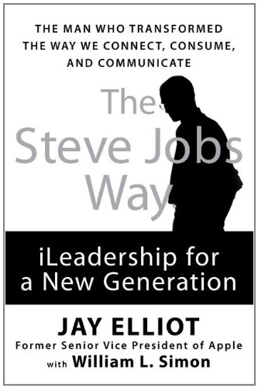
The Steve Jobs Way
iLeadership for a New Generation

Book Overview:
[paste take a ways here]

Click here to read reviews, extended summary and current pricing from Amazon.

Personal Notes About This Book:

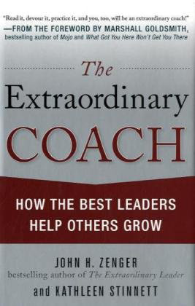
The Extraordinary Coach
How the Best Leaders Help Others Grow

Book Overview:
[paste take a ways here]

Click here to read reviews, extended summary and current pricing from Amazon.

Personal Notes About This Book:

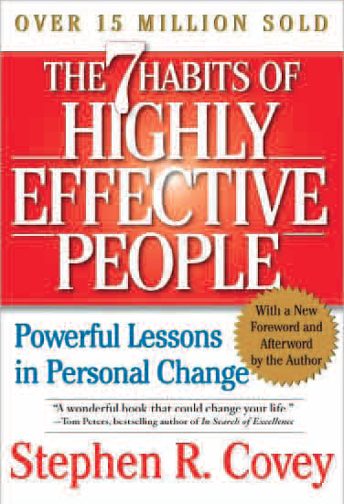
The 7 Habits of Highly Effective People
Powerful Lessons in Personal Change

Book Overview:
[paste take a ways here]

Click here to read reviews, extended summary and current pricing from Amazon.

Personal Notes About This Book:

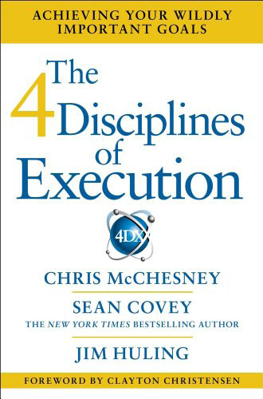
The 4 Disciplines of Execution
Achieving Your Wildly Important Goals

Book Overview:
[paste take a ways here]

Click here to read reviews, extended summary and current pricing from Amazon.

Personal Notes About This Book:

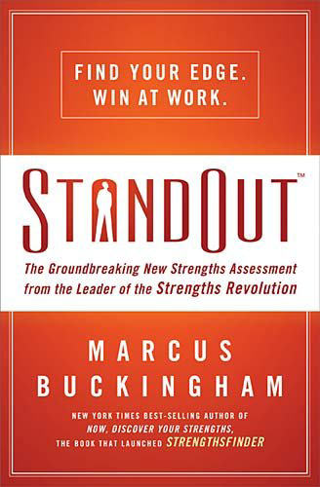
StandOut
Find Your Edge. Win at Work.

Book Overview:
[paste take a ways here]

Click here to read reviews, extended summary and current pricing from Amazon.

Personal Notes About This Book:

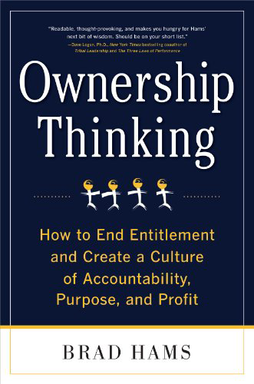
Ownership Thinking
How to End Entitlement and Create a Culture of Accountability,
Purpose, and Profit

Book Overview:
[paste take a ways here]

Click here to read reviews, extended summary and current pricing from Amazon.

Personal Notes About This Book:


One Big Thing
Discovering What You Were Born to Do

Book Overview:
[paste take a ways here]

Click here to read reviews, extended summary and current pricing from Amazon.

Personal Notes About This Book:

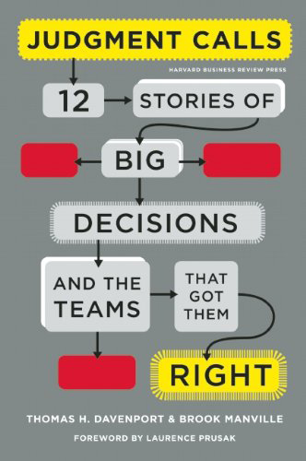
Judgment Calls
12 Stories of Big Decisions and the Teams That Got Them Right

Book Overview:
[paste take a ways here]

Click here to read reviews, extended summary and current pricing from Amazon.

Personal Notes About This Book:


How to Stop Worrying and Start Living

Book Overview:
[paste take a ways here]

Click here to read reviews, extended summary and current pricing from Amazon.

Personal Notes About This Book:

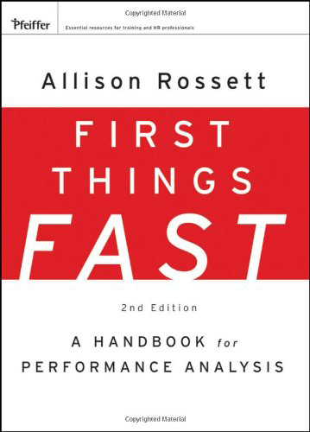
First Things Fast
A Handbook for Performance Analysis

Book Overview:
[paste take a ways here]

Click here to read reviews, extended summary and current pricing from Amazon.

Personal Notes About This Book:

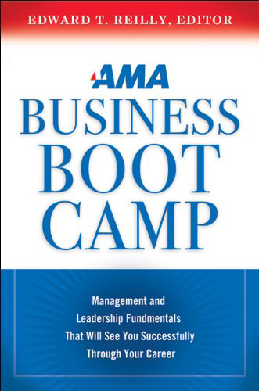
AMA Business Boot Camp
Management and Leadership Fundamentals That Will See You
Successfully Through Your Career

Book Overview:
[paste take a ways here]

Click here to read reviews, extended summary and current pricing from Amazon.

Personal Notes About This Book:

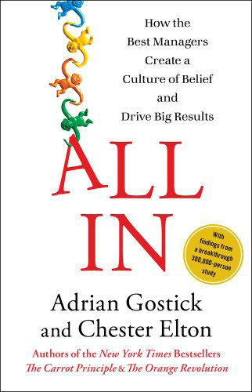
All In
How the Best Managers Create a Culture of Belief and Drive Big Results

Book Overview:
[paste take a ways here]

Click here to read reviews, extended summary and current pricing from Amazon.

Personal Notes About This Book:

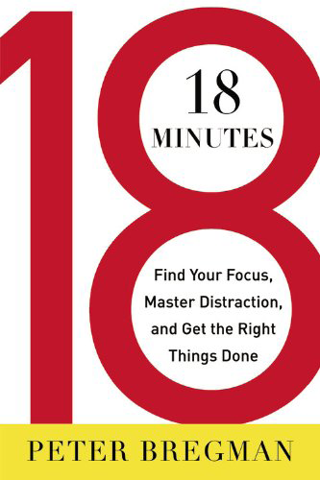
18 Minutes
Find Your Focus, Master Distraction, and Get the Right Things Done

Book Overview:
[paste take a ways here]

Click here to read reviews, extended summary and current pricing from Amazon.

Personal Notes About This Book:

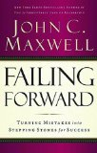
Failing Forward
Turning Mistakes into Stepping Stones for Success

Book Overview:
- Finalize your goal – the goal shapes the plan, the plan shapes the action, the action achieves the results
- Order your plan. If you neglect to plan you plan to fail.
- Risk failing by taking action.
- Welcome mistakes – embrace the learning from mistakes
- Advance based on your character – always a time when giving up is easier. There will be a defining moment
- Reevaluate your progress continually. Learn and adjust.
- Develop new strategies to succeed. Success is a continual process. There will never be a perfect plan – need to constantly reevaluate and adjust.

Click here to read reviews, extended summary and current pricing from Amazon.

Personal Notes About This Book:

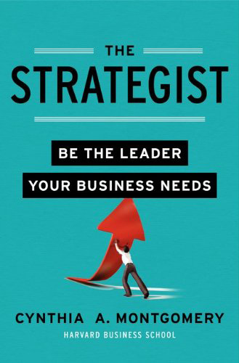
The Strategist
Be the Leader Your Business Needs

Book Overview:
[paste take a ways here]

Click here to read reviews, extended summary and current pricing from Amazon.

Personal Notes About This Book:


Greatness
The 16 Characteristics of True Champions

Book Overview:
[paste take a ways here]

Click here to read reviews, extended summary and current pricing from Amazon.

Personal Notes About This Book:

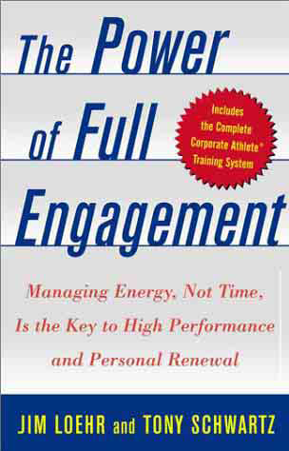
The Power of Full Engagement
Managing Energy, Not Time, is the Key to
High Performance and Personal Renewal

Book Overview:
[paste take a ways here]

Click here to read reviews, extended summary and current pricing from Amazon.

Personal Notes About This Book:


Relax, It’s Only Uncertainty
Lead The Way When The Way Is Changing

Book Overview:
[paste take a ways here]

Click here to read reviews, extended summary and current pricing from Amazon.

Personal Notes About This Book:

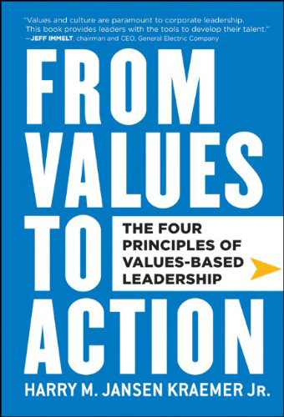
From Values to Action
The Four Principles of Values-Based Leadership

Book Overview:
[paste take a ways here]

Click here to read reviews, extended summary and current pricing from Amazon.

Personal Notes About This Book:

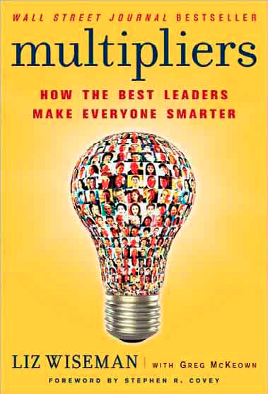
Multipliers
How the Best Leaders Make Everyone Smarter

Book Overview:
[paste take a ways here]

Click here to read reviews, extended summary and current pricing from Amazon.

Personal Notes About This Book:

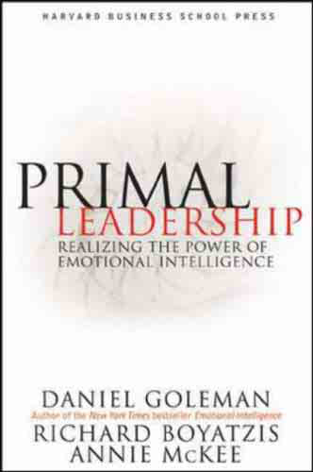
Primal Leadership
Realizing the Power of Emotional Intelligence

Book Overview:
[paste take a ways here]

Click here to read reviews, extended summary and current pricing from Amazon.

Personal Notes About This Book:

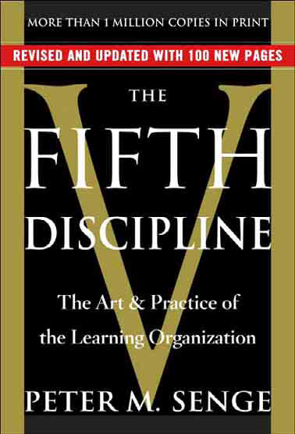
The Fifth Discipline
The Art and Practice of the Learning Organization

Book Overview:
[paste take a ways here]

Click here to read reviews, extended summary and current pricing from Amazon.

Personal Notes About This Book:

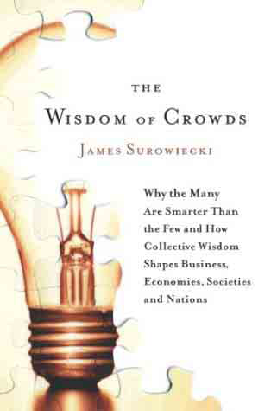
The Wisdom of Crowds
Why the Many Are Smarter than the Few and How Collective Wisdom
Shapes Business, Economies, Societies and Nations

Book Overview:
[paste take a ways here]

Click here to read reviews, extended summary and current pricing from Amazon.

Personal Notes About This Book:

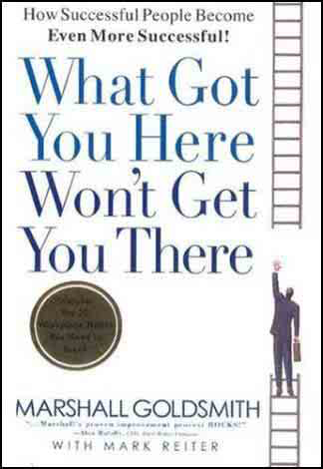
What Got You Here Won’t Get You There
How Successful People Become Even More Successful!

Book Overview:
[paste take a ways here]

Click here to read reviews, extended summary and current pricing from Amazon.

Personal Notes About This Book:

